Assignment 4: Written

CSC 226

July 30, 2018

Ryan Woodward

V00857268

**1.**

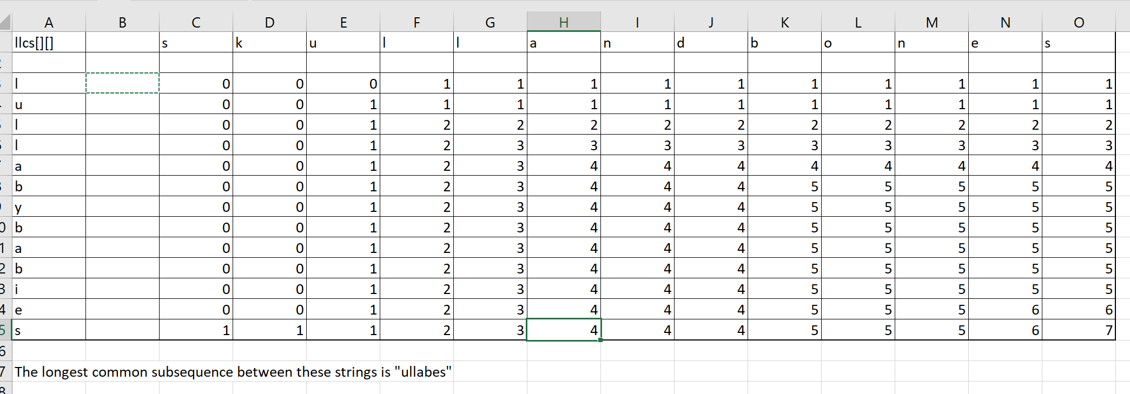

**2.**

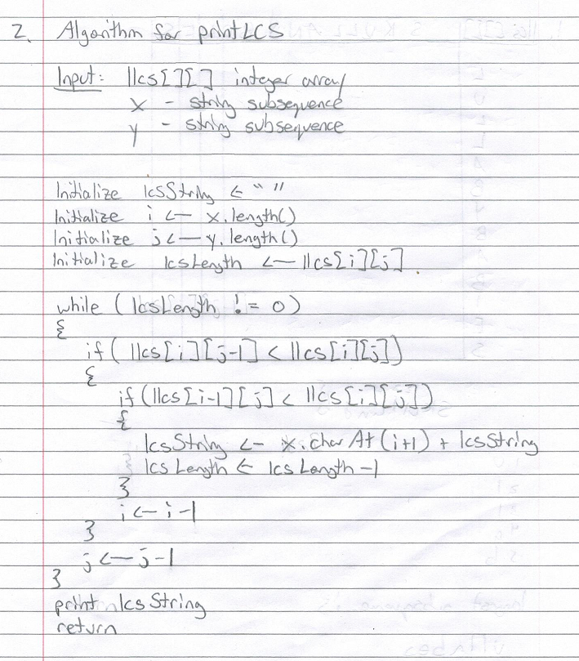

**3.**

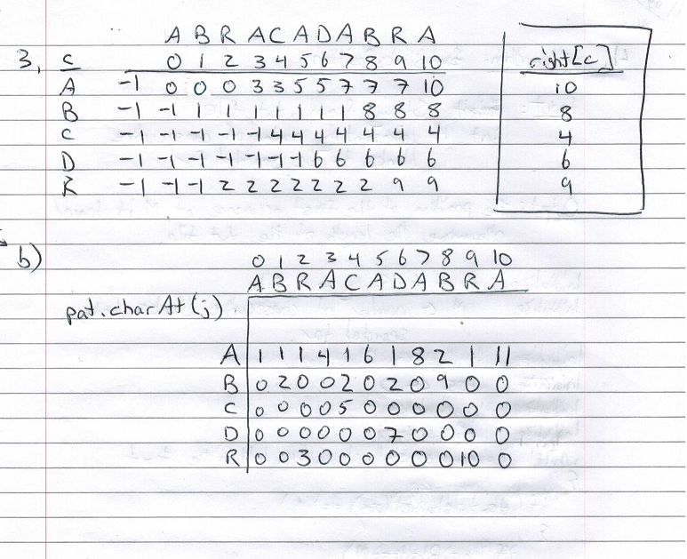

**4.**

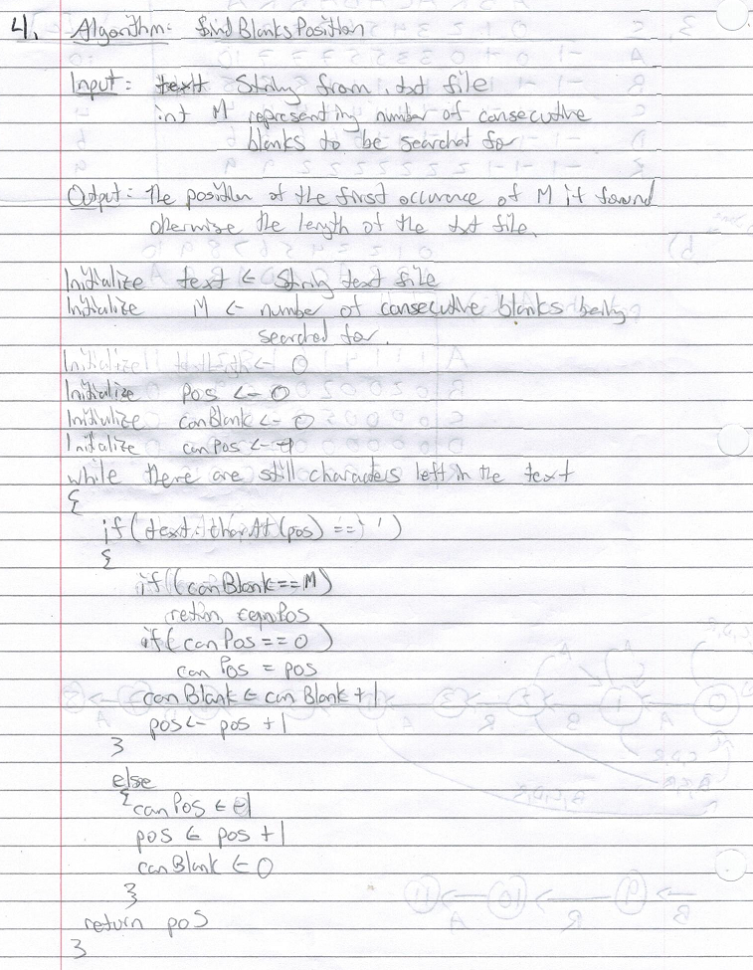

The running time of this algorithm is O(N) where N is the worst case scenario and the algorithm has to take the entire length of the text string in order to find the number of consecutive blanks.